**Department of Electrical and Computer Engineering**

**North South University**



**Junior Design Project CSE299 Project Weekly Update**

# Graph Based ML Model

|  |
| --- |
| **Faculty Advisor : Mohammad Shifat E-Rabbi** |

**Group - 04**

|  |  |
| --- | --- |
| **Name** | **ID** |
| **Rahiq Rahman** | **2233595042** |
| **Zahid Hasan Rana** | **2231822042** |

# *Week 4 (June 26th, 2025 – July 2nd, 2025)*

* Modification of the Bipartite Graphs:
  + Instead of taking manual input of the interactions between two nodes, a sample dataset suitable for Bipartite graph was used.
  + A task selection option was added where a specific graph-based task can be chosen from the list of implemented graph-based tasks.

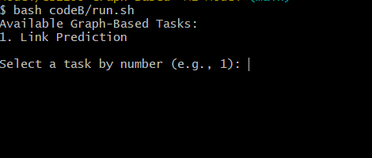

* + After the selection of task, the name of the Model and Dataset can be used as an argument to select a specific model and dataset for that particular task.

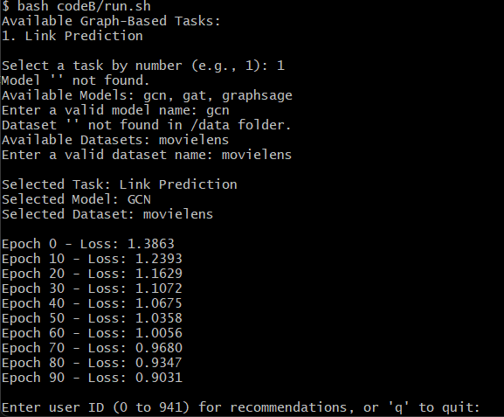

* + Model and Dataset can also be set as an argument when running the command to run the program.

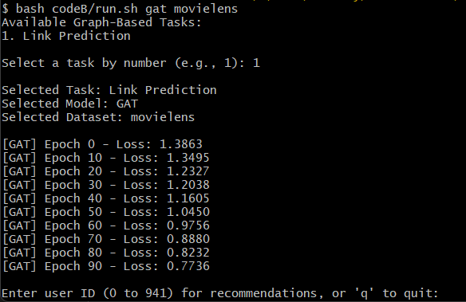

* + The model GAT and GraphSAGE has been added for the implemented graph-based tasks.
  + Link Prediction using GCN

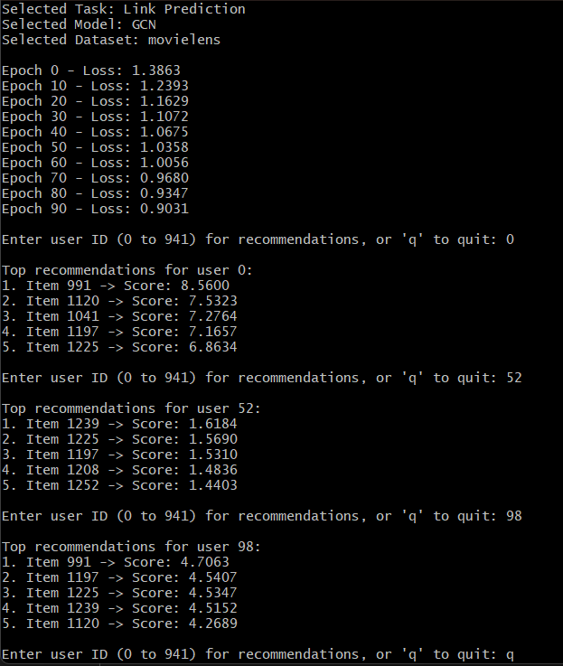

* + Link Prediction using GAT

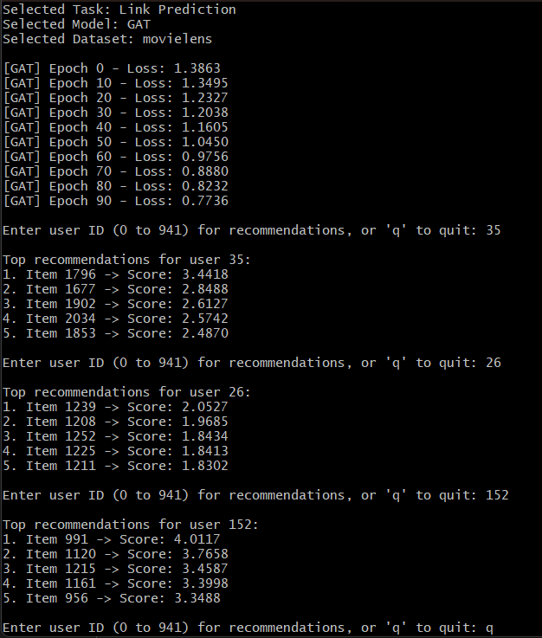

* + Link Prediction using GraphSAGE

